

Faculty

Mr. Vinh Anh Nghiem Quan

GROUP: NTD Group

MEMBER:

Ho Ngoc Minh Nhat

Phan Nguyen Nhat Dang

Nguyen Cong Thien

CLASS: CP202208L

**Hue, 03-Dec-2022**

Project Name:

ePROJECT

**COURSE CPISM, ACCP OV-7023**



THUA THIEN HUE CENTER OF INFORMATION TECHNOLOGY

**HUE-APTECH COMPUTER EDUCATION CENTER**

BAKERZ BITE

CERTIFICATE

This is to certify that

Group: CP202208L

Members:

HO NGOC MINH NHAT

PHAN NGUYEN NHAT DANG

NGUYEN CONG THIEN

Has successfully designed, developed

**THE SITE “BAKERZ BITE”**

Submitted by: Vinh Anh Nghiem Quan

Date: Dec-01-2022

Signed by:…………………

TABLE OF CONTENTS

Problem definition 3

Customer requirement specification 4

Project plan 7

TASK SHEET 9

Site Map 11

Content of page 12

GUI design 13

Screenshots (Home page) 15

Checklist of Validations 24

Submission Checklist 25

APPENDIX A – User guide 26

APPENDIX B – Install guide 27

Problem definition

Since its launch, “**Bakerz Bite**” has developed into a reputable bakery & café, specializing in baked goods, passionately made from the finest ingredients.

Bakerz Bite offers a wide range of baked goods made fresh in-store every day. The bakery chain offers more than 300 different kinds of baked goods, including artisan pastries, gourmet cakes and desserts, and handcrafted beverages.

The brand takes pride in sourcing and using carefully selected ingredients and promises to bring freshness and quality to its customers. Bakerz Bite continues to expand and embrace innovation in all markets.

We believe and are dedicated in delivering premium quality products. So we only use real butter, cream and unbleached flour. We treat our Customers as our family and will not use any ingredient which we will not want to feed ours.

We are supposed to create a Single-Page-Application and responsive Website for them with the below mentioned requirement specifications.

The website is to be developed for the Windows Platform using HTML5, JavaScript and Geolocation. The site should work well in all leading browsers including Chrome, IE, Firefox etc.

It is created with the below requirement specifications.

Customer requirement specification

**Input to the system**

* **Sources:** Internet, books, newspapers, magazines, etc.
* Reference: cookie.com, auctions.donq.co.jp, starbuck.com, etc.

**Output from the system**

* The site must contain sections like Cakes, Pastries, Cookies, Pies etc. and should consist various items.
* Clicking on any item should open pop-up window with images of product along with the description and detailed specification (ingredients).
* Site should also consist of a section “Merchandise’ with “Bakerz Bite” branded Mugs, Bags, Glasses, Trays listed into it.
* Filters should be provided for assisting user to select products of their choice.
* Gallery should be added for viewing different images.
* Feedback and Rating must be allowed to enter by the viewer
* Site map, Gallery, about us, FAQ link, Contact us link must be added.
* About Us and Contact Us: This menu option should display Email id, address, and contact number.
* Section for various offers in the store should be provided with listing of offers with details.
* Color combination must be uniform throughout the project.
* Navigation must be smooth.

**Process involved in the system** (Functional specifications)

* Using Angular to present the images
* Using Bootstrap library to create better design

**Hardware requirements**

* Intel Core i3/i5 Processor or higher
* 8 GB RAM or above
* Color SVGA
* 500 GB Hard Disk space
* Mouse
* Keyboard
* 64 Megabytes of RAM or better

**Software requirements**

* Frontend: HTML5, CSS, Bootstrap, JavaScript, jQuery, AngularJS,
* Data Store: JSON files or TXT files
* Operating Portal: Windows
* Browsers: Edge, Chrome, Mozilla Firefox, Safari

Project plan

**Project details**

* **Name of client:** Bakerz Bite
* **Date of project plan:**
* Start Date: 01-Nov-2022
* End Date: 01-Dec-2022
* **Project Vision:**

(Define the project vision/objective as stated by the client)

Built web application based on knowledge to learn: HTML, CSS, Bootstrap, JavaScript,Angular, etc.

* **Scope:**
* User can navigate through any category for the information.
* User can learn recipe for each products and imagine the flavor from description
* Users can use menu section to view different images as well.
* Many page features are available to get access to: Site map, Menu, About us, Contact us link.

**Project organization with responsibilities and authorities:**

|  |  |
| --- | --- |
| **Student** | **Role** |
| **Ho Ngoc Minh Nhat** | Analyzing the website requirements and distributing the tasks based on member’s suggestions; clarifying and suggesting initial specific requirements and page structure; designing logo; designing banner; designing UI; designing the interface; writing user manual; counting user function; count down function; building feedback; building home, product, site map, detail, gallery page; writing report; working with database |
| **Tran Cong Thien** | Suggesting initial specific requirements and page structure; helping designing the interface; edit image; building about page |
| **Phan Nguyen Nhat Dang** | Searching, collecting images; helping in the image editing process; assisting in the UI designing and user manual writing process; building chat, modal; building map; building contact page |
| **All members** | Testing the website and correcting the mistakes (fixing bugs) |

TASK SHEET

|  |  |  |  |  |  |  |
| --- | --- | --- | --- | --- | --- | --- |
| **Task sub**  **division** | **Description** | **Start date** | **End date** | **Execution date** | **Group name** | **Status** |
| **1.Preparation** | - Define the problem  - Make a plan  - Find document  - Write report | 01-Nov-2022 | 03-Nov-2022 | 3 | NTD Group | FINISHED |
| **2. Analysis**  **Requirements** | - Identify the entities of the system  - Making the process for converting data from input to output information | 04-Nov-2022 | 07-Nov-2022 | 3 | NTD Group | FINISHED |
| **3. Designing** | - Design interface  - Design banner  -Create sitemap | 08-Nov-2022 | 19-Nov-2022 | 11 | NTD Group | FINISHED |
| **4.Development** | Finish basic pages | 20-Nov-2022 | 23-Nov-2022 | 4 | NTD Group | FINISHED |
| **5. Testing** | - UI  -Function | 24-Nov-2022 | 26-Nov-2022 | 3 | NTD Group | FINISHED |
| **6. Fixing bug & Editing** | - UI  - Function | 26-Nov-2022 | 28-Nov-2022 | 3 | NTD Group | FINISHED |

Site Map

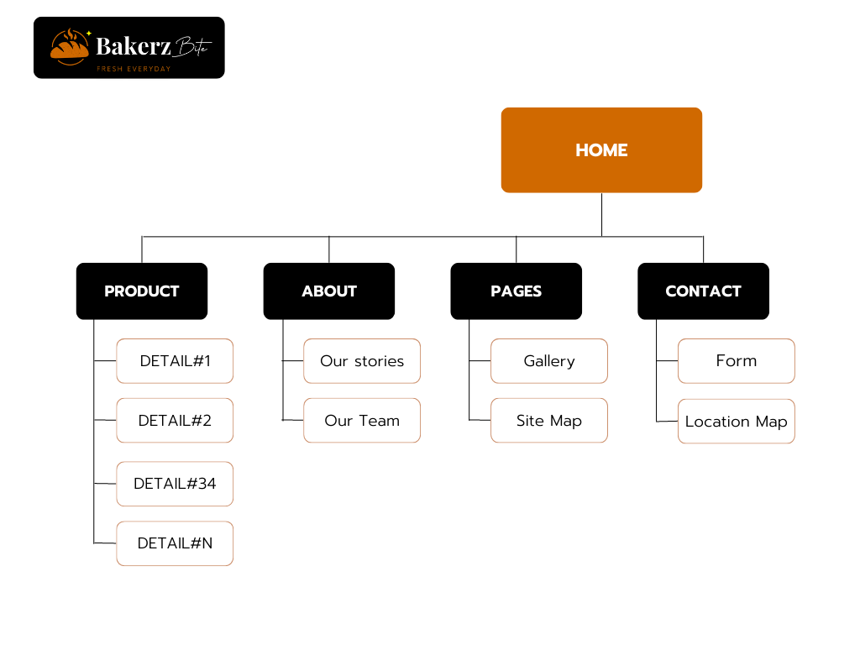

Content of page

|  |  |  |
| --- | --- | --- |
| **No** | **Page name** | **Description** |
| 1 | index.html | Home page |
| 2 | products.html | Products page |
| 3 | contact-us.html | Contact Us page |
| 4 | about-us.html | About Us page |
| 5 | sitemap.html | Sitemap page |
| 6 | details.html | Details page (1 – 20 items) |
| 7 | success.html | Success page |

GUI design

## Page design

|  |  |
| --- | --- |
| **Property** | **Value** |
| **Background-color** | #fff |
| **Font – family** | "Roboto”, Sans-serif, Play Fair Display, |
| **Menu – Font size** | 16px |
| **Menu – Font color** | #FDF5EB |
| **Title – Font size** | 80px, 20px, 16px |
| **Title – Font color** | #FDF5EB |
| **Text – Font size** | 14px |
| **Text – Font color** | #FDF5EB;  #1E1916; |
| **Icon – Font color** | #ffdd00;  #3c3c3c |
| **Border – width** | 1px |
| **Border – style** | solid |
| **Border – color** | #c3c3c3 |
| **Border – radius** | 10px |
| **Link – hover color** | #ffdd00;  #3c3c3c |

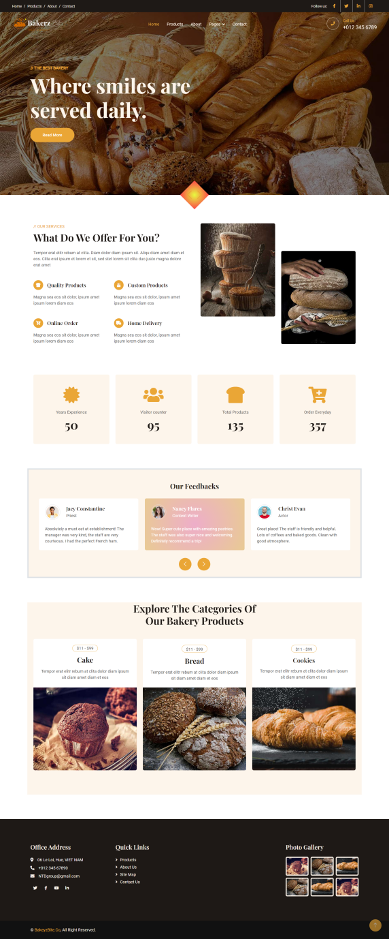

Screenshots (Home page)

* Navbar with Fade In animation and auto sticky top when scroll down.
* Carousel which is can slide by mouse and touch, also have button for next and previous.
* Different value of translate (Y) make fantastic layout.
* 4 facts with Count Up animation and auto Count Up function.
* Image card with hover effect to attract customer.
* Footer with available links.

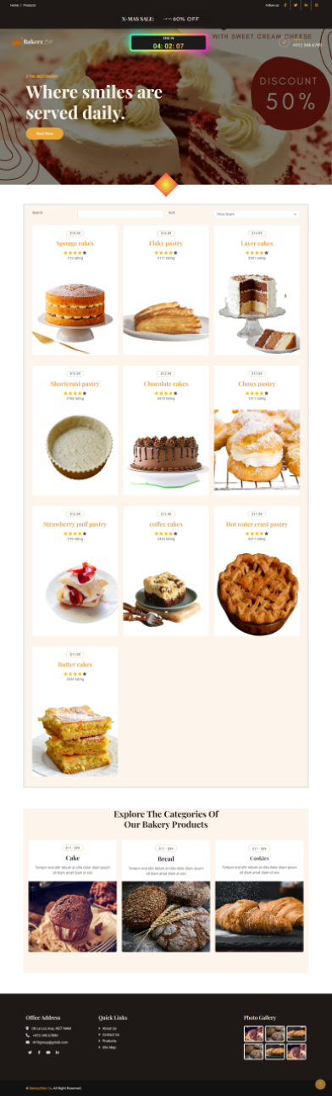

Screenshots (Products page)

* Navbar with Fade In animation and auto sticky top when scroll down.
* Carousel which is can slide by mouse and touch, also have button for next and previous.
* Wonderful count down RGB clock.
* Searching products is available.
* Sort by: price, name, rating.
* Fantastic hover effect on card products.
* Footer with available links.

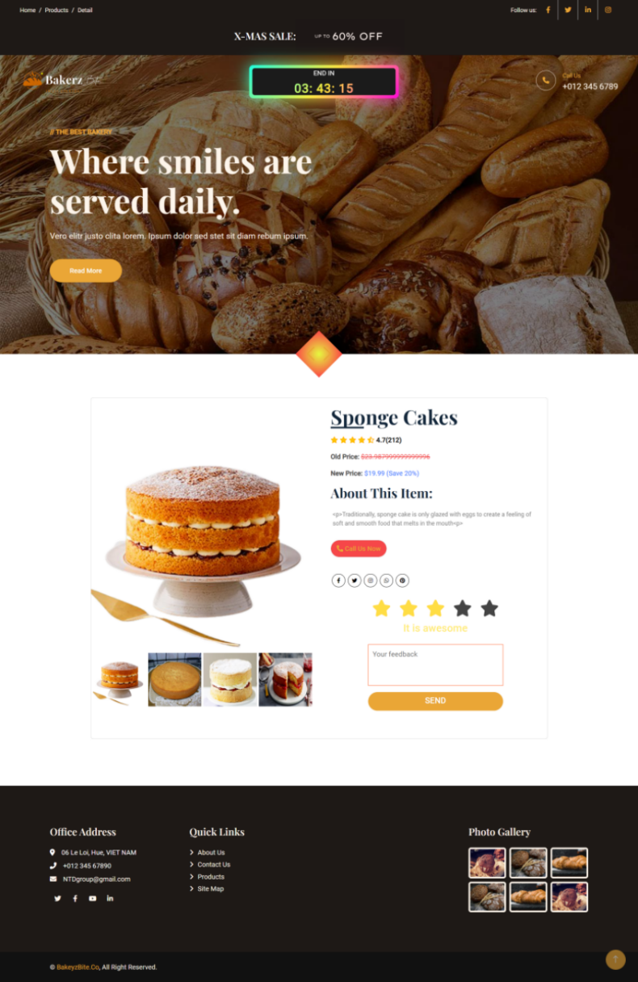

Screenshots (Detail page)

* Navbar with Fade In animation and auto sticky top when scroll down.
* Carousel which is can slide by mouse and touch, also have button for next and previous.
* Wonderful count down RGB clock.
* Calling button to order immediately.
* Rating start and sending feedback are also available.
* Fantastic hover effect on card products.
* Footer with available links.

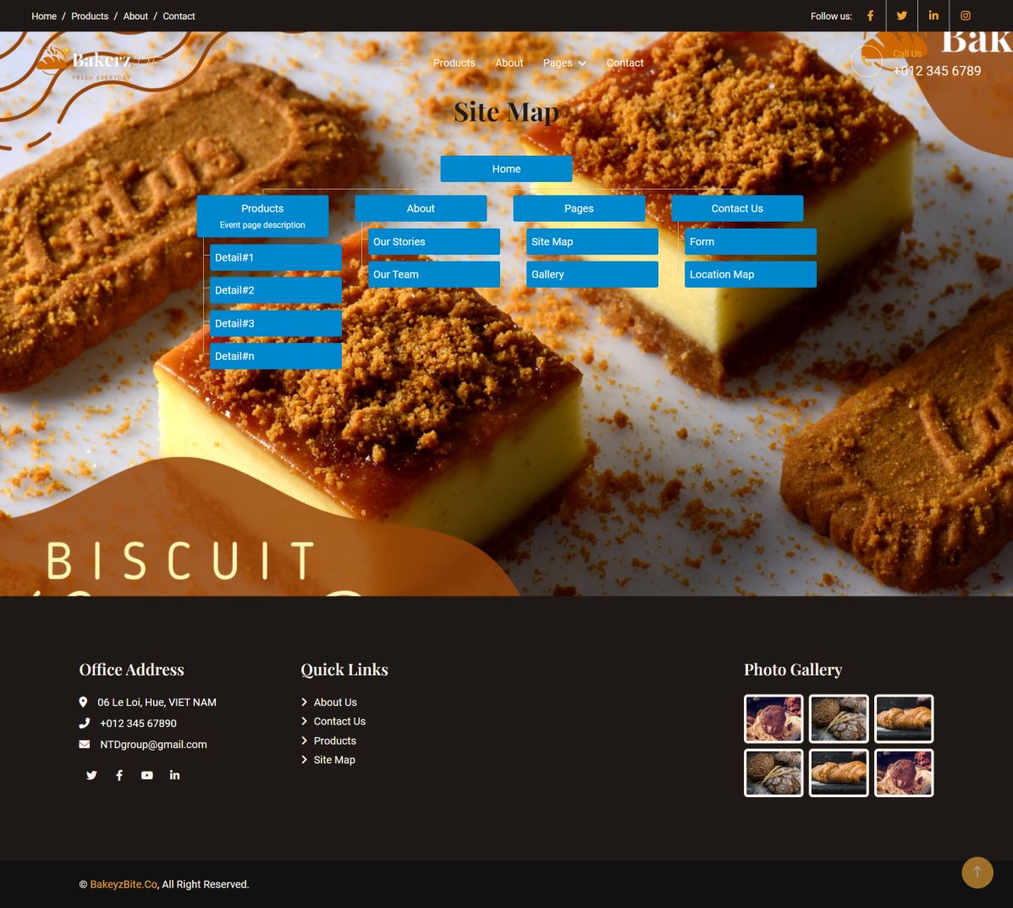

Screenshots (Products page)

* Navbar with Fade In animation and auto sticky top when scroll down.
* Site with available link buttons with hover effect.
* Beautiful gradiant background.
* Footer with available links.

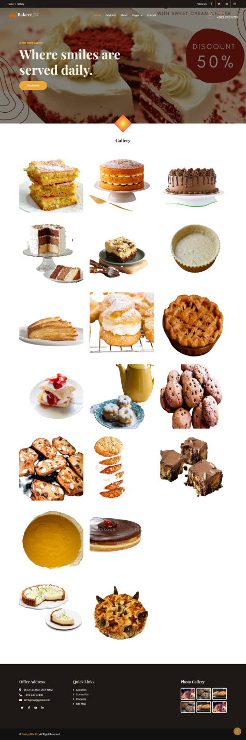

Screenshots (Gallery page)

* Navbar with Fade In animation and auto sticky top when scroll down.
* Carousel which is can slide by mouse and touch, also have button for next and previous.
* Calling button to order immediately.
* Fantastic hover effect on card products.
* Footer with available links.

**Screenshots (Contact page)**

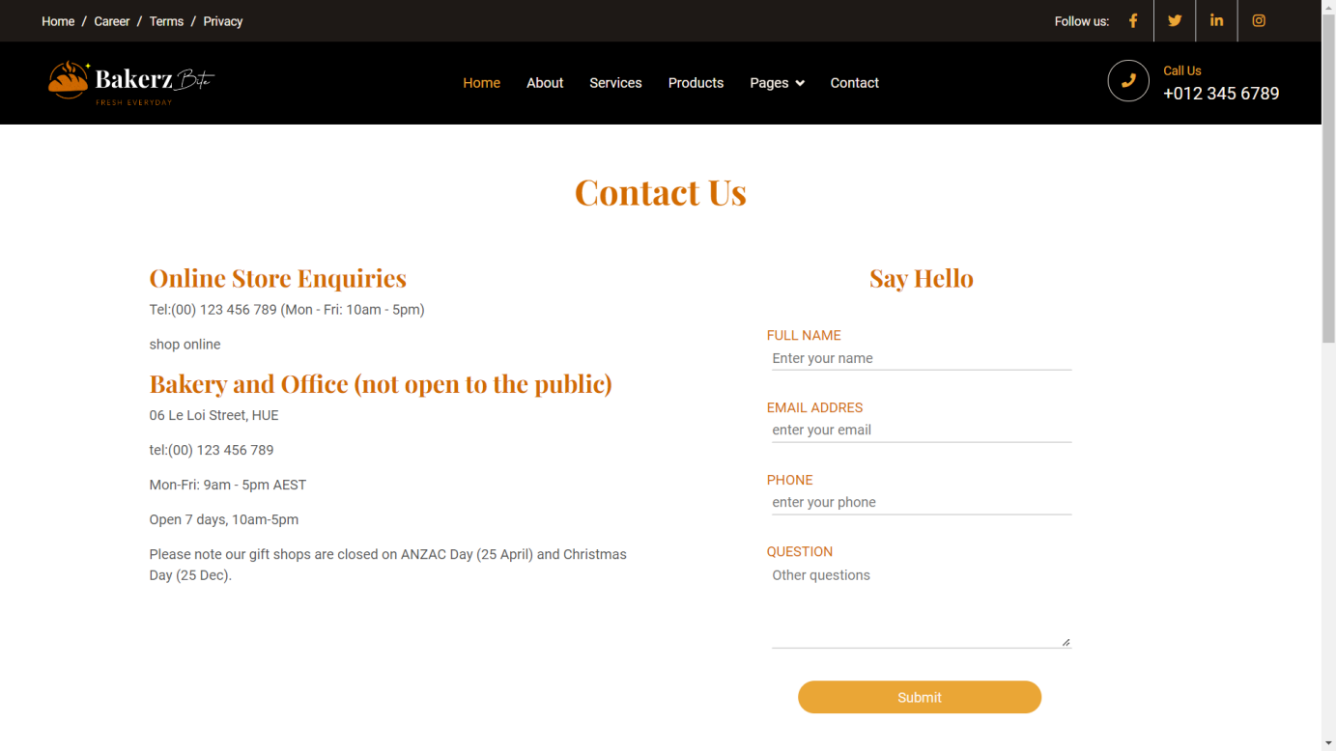

**Screenshots (Contact page)**

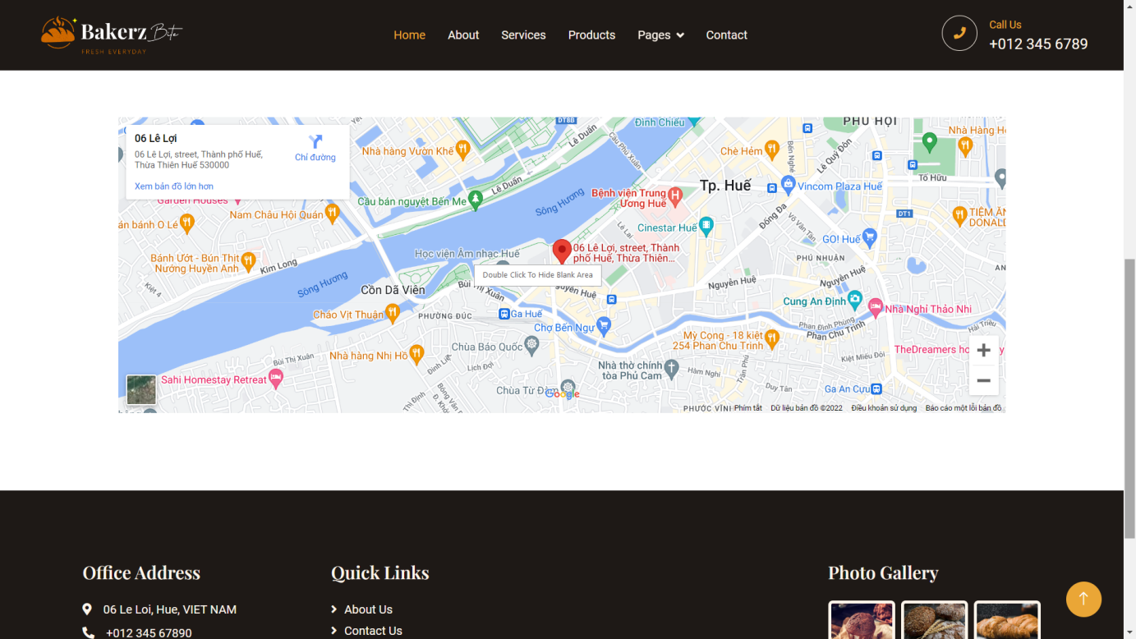

**Screenshots (About page)**

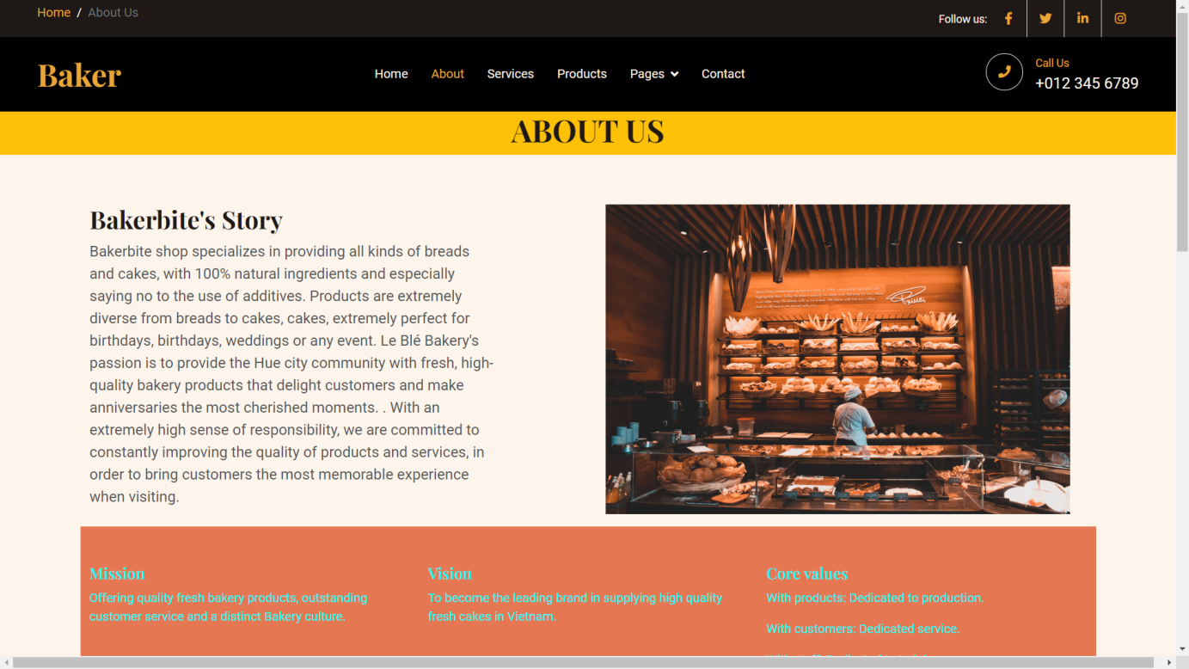

**Screenshots (About page)**

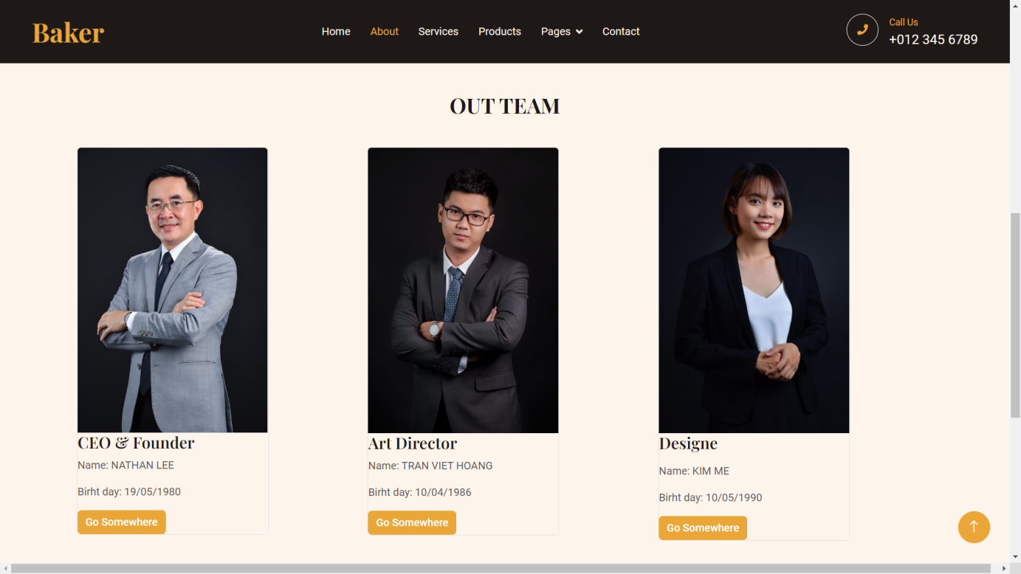

Checklist of Validations

|  |  |
| --- | --- |
| **Option** | **Validated** |
| Do all text links lead to the appropriate Web site? | Yes |
| Do all the image links lead to the appropriate Web site? | Yes |
| Are all the images and links clearly visible on the page? | Yes |
| Is the Web page opening properly in all the tested Web browsers? | Yes |
| Is the Web page taking too long to load? | No |
| Is the navigation sequence correct through all the Web pages on the site? | Yes |
| Is the JavaScript code working as expected in all click events? | Yes |

Submission Checklist

|  |  |
| --- | --- |
| **Particulars** | **Result(Yes/No)** |
| Are all the users able to view the images and links? | Yes |
| Have all the views, modules, and controllers been properly integrated and is the site functional as a Single Page Application? | Yes |
| Are the GUI contents devoid of spelling mistakes? | Yes |
| Is the application user-friendly? | Yes |
| Is the Web site launching correctly in the browser? | Yes |

APPENDIX A – User guide

Website display well on the browser :

- Internet Explorer

- GoogleChrome

- Firefox

APPENDIX B – Install guide

- Copy folder Bakerz Bite and paste anywhere in the disk of your computer

- Open file index.html using browser to use

**COMMENTS OF FACULTY**